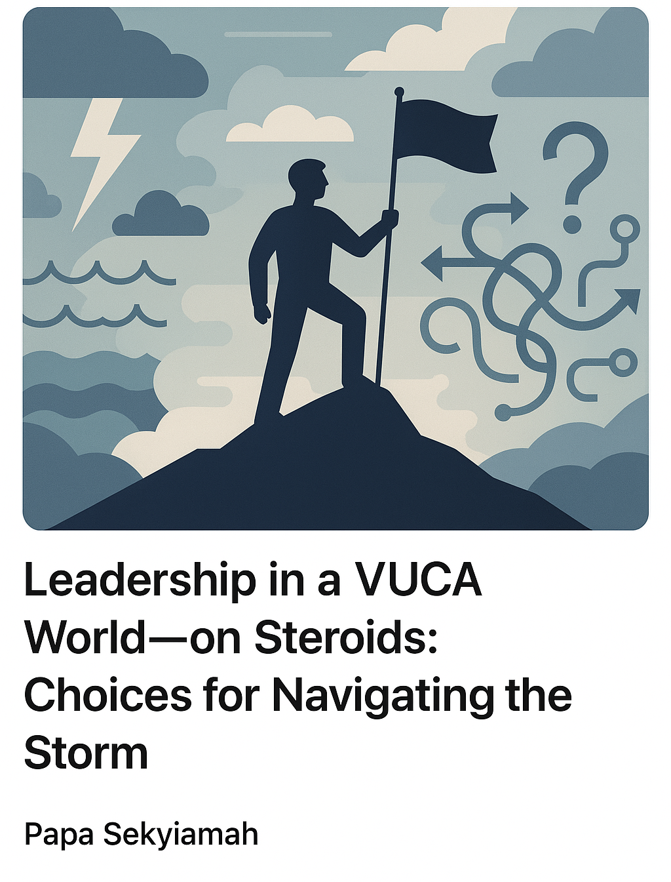
Leadership Coach, Chartered Director (IoDSA), Chairman Nedbank Lesotho

We are increasingly living in a complex geopolitical and economic world. A couple of years ago, the term VUCA—Volatile, Uncertain, Complex, Ambiguous—was popularised to describe the headwinds of change.
But today, we face a VUCA world on steroids.
The global rules-based order is fraying under geopolitical tensions and shifts in sovereign behaviour. Climate disasters—from floods to fires and famines—remind us of our planet’s fragility. Artificial Intelligence promises both opportunity and upheaval in how we work, govern, and connect. And in the background, a slowly aging and shrinking global population raises unsettling long-term questions.
Starting and running a successful business—or leading any enterprise—in this context may seem especially daunting. Yet, the old adage remains true: "We always retain the power of choice." Here are some choices leaders can make to navigate this world of amplified VUCA, inspired by the timeless wisdom of African proverbs.
Go Slow to Go Fast
“Tomorrow belongs to those who plan for it today” — African Proverb
In the face of rapid change, our instinct is often to cling to what we know and do things as we have always done them. However, as counter intuitive as it seems, slowing things down to properly assess trends, simplify the issues, generate potential scenarios and develop strategic options can be the difference between doing things right and doing the right things.
Slowing down isn’t indecision. It’s intentionality.
Listen, and Lead with Humility, Not Heroics
“Ears that do not listen to advice, accompany the head, when it is chopped off.” — Nigerian Proverb
While modern leadership celebrates collaboration and decentralisation, we still often idolise the lone hero-leader. Leaders are sometimes drowning in information but starving for wisdom. Today, it’s not enough to listen within our usual echo chambers. We must deliberately broaden our networks, seek diverse perspectives, and interrogate our own blind spots. Leadership in a VUCA world is not about having all the answers—it’s about fostering the space where better questions and ideas are asked and generated.
Listening, deeply and with humility is a radical leadership act.
Don’t Wait for Permission to Lead
“A boat does not know, who the leader is. When it capsizes everyone gets wet.”— Madagascan Proverb
In a VUCA world, the risks of bad decisions are heightened. Traditional decision-making systems might not work well and risk closing the door after the horse has bolted. As a leader, whether with formal authority or not, recognise you do not need permission to lead. The VUCA world is your permission to ask the right questions, frame issues, facilitate solutions and drive accountability.
Leadership is no longer positional. Recognise that leadership can come from anywhere.
Be Courageous
“Smooth seas do not make skilful sailors” - Ghanaian proverb
Leading in a VUCA world takes more than skill—it demands courage. The courage to slow down. To listen. To resist being the hero. To lead without being asked to. To lead with empathy and moral clarity. To acknowledge mistakes and learn from them
Without courage, none of the other choices can be exercised.
Final Word
The VUCA world is not a temporary storm to be weathered. It’s the new climate. But within the turbulence lies profound possibility—for reinvention, collective intelligence, and more grounded leadership.
We may not control the wind, but we can choose how to set our sails.
Papa Sekyiamah

